Schema Based File account import

* Introduction:  
  Saviynt EIC offers OOB capability to automated manual recon of accounts through schema-based account import.  
    
    
  How it works:  
    
  Saviynt has schema-based account jobs which can be configured to automate recon of manual accounts.  
    
    
  Prerequisites:   
    
  The Schema-based jobs require SAV and csv files for importing data, The sav files need to be present under the File directory in SAV files and csv files needs to be present in Datafiles. Ensure that the CSV file name must start with the string that you specified for the **FileNameStartswith**property.

Also Ensure that the SAV file name is suffixed with Accounts.

Integration Steps:  
1) Create a Sav file and put it in the sav folder under file directory (Accounts.sav)  
  
Sample SAV file for uploading accounts   
  
  
SystemName=SampleSS

FileNameStartswith=SchemaAccounts

DELETEACCOUNTENTITLEMENT=NO

ACCOUNT_NOT_IN_FILE_ACTION=NOACTION

IGNOREFIRSTLINE=True

FILEIMPORTDELIMETER=,

#EMAILTEMPLATE=

OVERWRITE_USER_ASSIGNED=TRUE

ACCOUNTNAME,endpointname,status,CUSTOMPROPERTY1  
  
Lets understand the Sav file  
SystemName – define the name of the security system  
FileNameStartswith – Multiple csv files can be present in the datafiles folder and it is important to identify which file is going to be picked  
DELETEACCOUNTENTITLEMENT = Specify If you want to remove the account to entitlements mapping for accounts existing in EIC.

The options are:

* **Yes:**Removes the account to entitlements mapping.
* **No:**Does not remove the accounts to entitlements mapping.

FILEIMPORTDELIMETER = Specify the delimiter used  
  
IGNOREFIRSTLINE = To ignore the first line which defines the column in the csv file.  
  
ACCOUNTNAME,endpointname,status,CUSTOMPROPERTY1 = This defines the order of column in the csv file.  
  
  
  
2) Once the Sav file has been created and put in the sav folder under files, Create the csv file in the format defined in the sav file.  
Sample csv file  
  
  
ACCOUNTNAME,endpointname,status,ABCD

DocUsername1ACC01,SampleED,1,abcd  
  
  
Here the first line defines the column so we have defined Ignorefirstline = true in the sav file.  
  
  
  
3) Once both the files have been put in the respective folders. Head to Job control panel in EIC and create a new job under job type File based Accounts import (SchemaAccount) and schedule it  
  
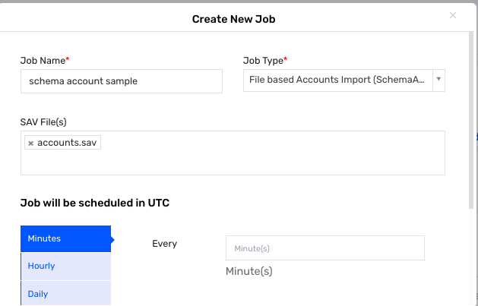

4) Once the job has been run successfully, the csv file will be archived and moved to success folder. If the job has failed for some reason, it will move to fail folder .  
  
  
**Account and Entitlement Correlation.**  
  
Account and Entitlements can be imported as part of same file where the correlation will take place.  
  
The following sav file can be used for that  
  
Import_Accounts.sav  
  
  
FileNameStartswith=SchemaAccounts

DELETEACCOUNTENTITLEMENT=NO

ACCOUNT_NOT_IN_FILE_ACTION=NOACTION

IGNOREFIRSTLINE=True

FILEIMPORTDELIMETER=,

#EMAILTEMPLATE=

OVERWRITE_USER_ASSIGNED=TRUE

ACCOUNTNAME,endpointname,status,CUSTOMPROPERTY1, entitlementtype, entitlement_value  
  
  
  
**Troubleshooting**:  
  
The most common error in Schema Account Error would be the File not found .  
  
  
Resolution  
Make sure that the latest csv files are present in the datafile folder and the sav files are present.